**SWARNASEKHAR DUTTA , IT 5TH Sem, 11**

Program 1

public class Name

{

public static void main(String args[])

{

System.out.println("Swarnasekhar Dutta");

}

}

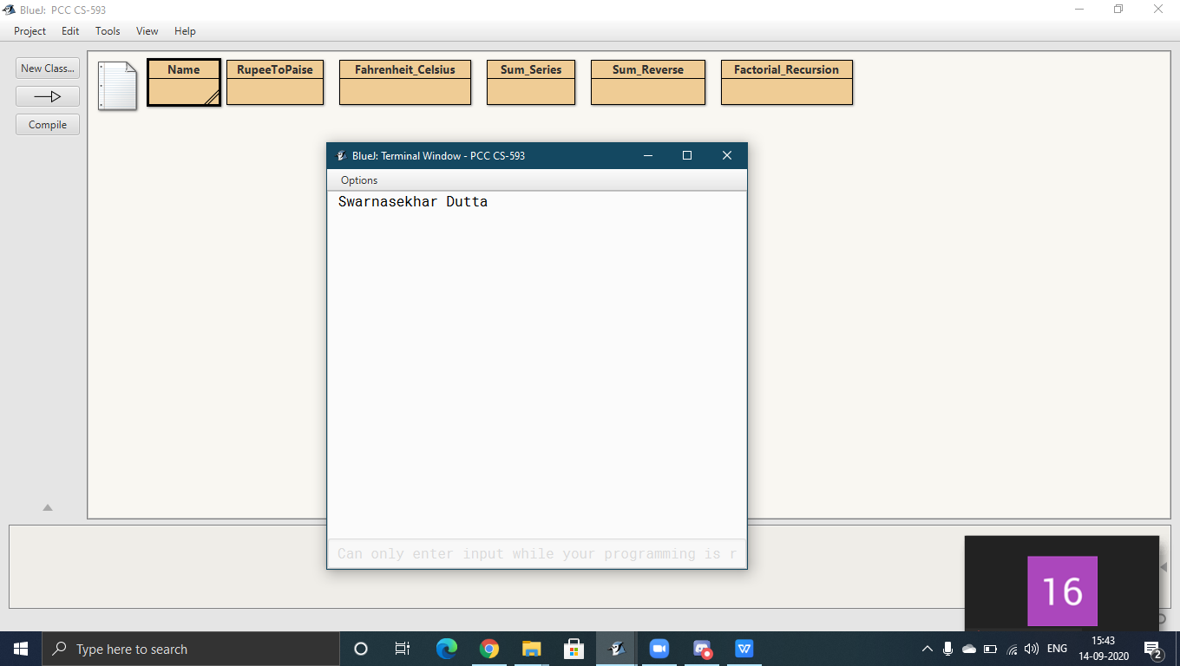

Program 2

import java.util.*;

public class RupeeToPaise {

public static void main(String[] args) {

double p;

Scanner sc=new Scanner(System.in);

p = sc.nextDouble();

System.out.println("Price in Rupee: " + (int) (p * 100));

}

}

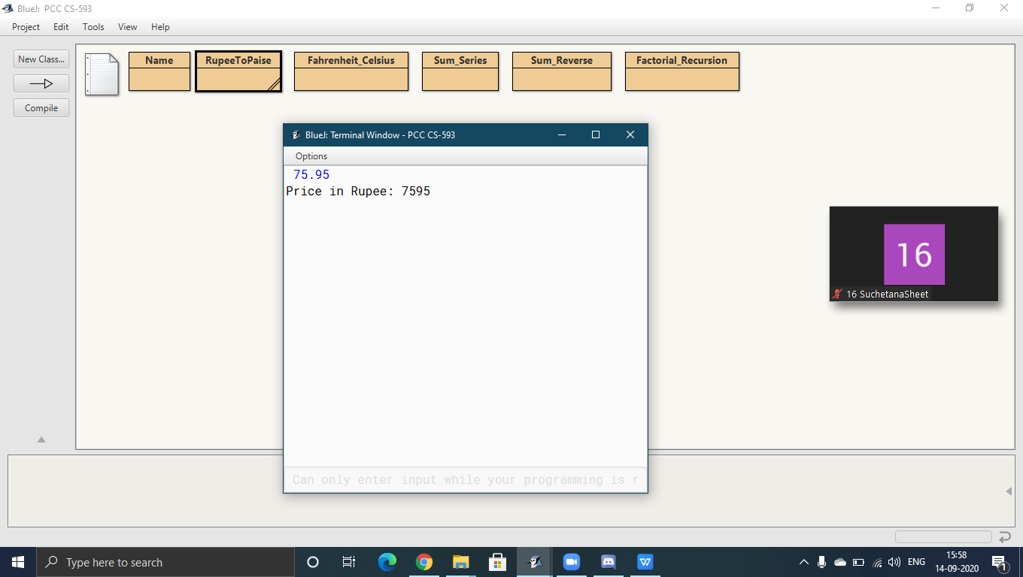

Program 3

import java.util.*;

public class Fahrenheit_Celsius {

public static void main(String[] args) {

double fah;

Scanner sc=new Scanner(System.in);

fah=sc.nextDouble();

double cel = (fah - 32) / 1.8;

System.out.println("Celcius: " + cel);

}

}

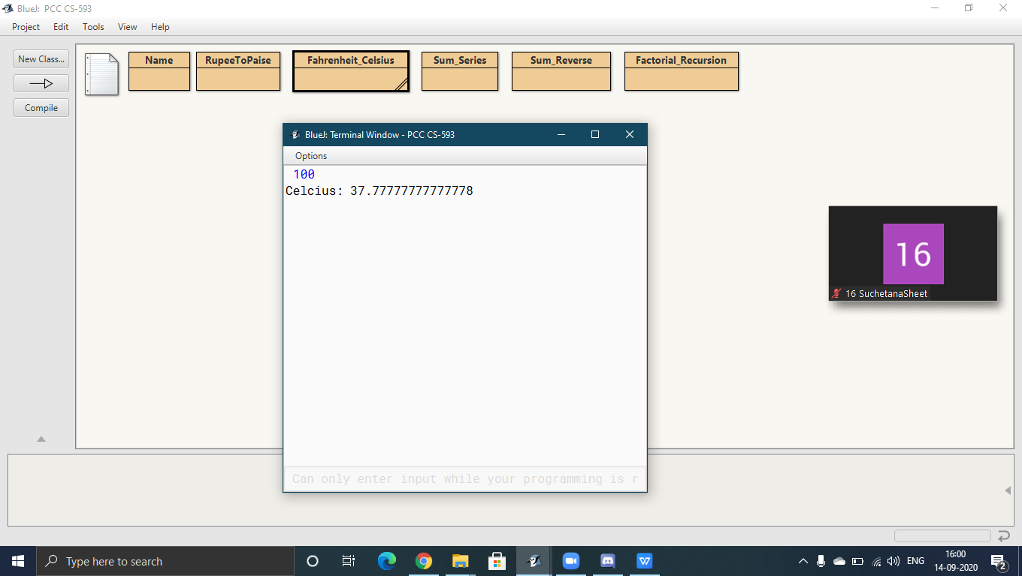

Program 4

import java.util.*;

public class Sum_Series

{

public static void main(String[] args)

{

Scanner sc=new Scanner(System.in);

int n = sc.nextInt();

double series = 0.0;

for (int i = 1; i <= n; i++)

series += 1.0 / i;

System.out.println("Series : " + String.format("%.2f", series));

}

}

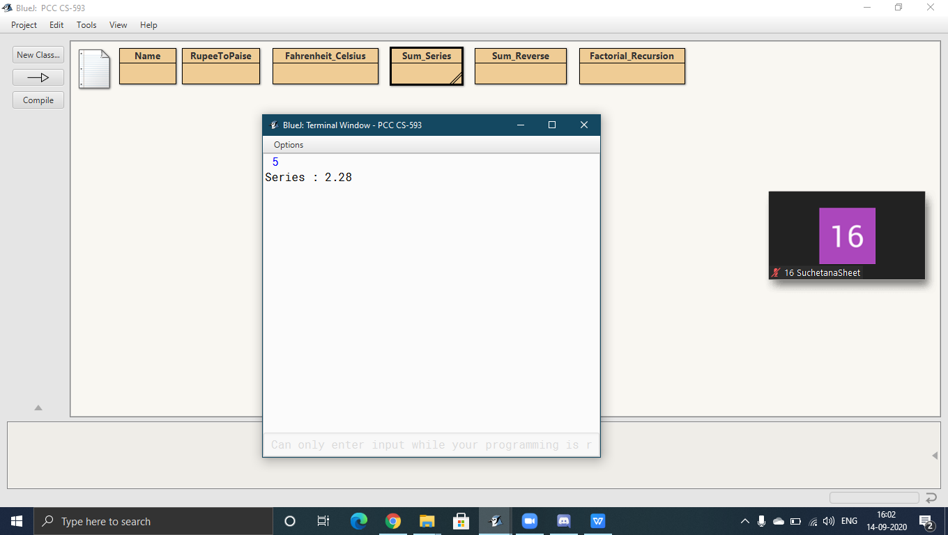

Program 5

import java.util.*;

class Operations

{

int reverse(int n)

{

int rev = 0;

int copy = n;

while (copy != 0)

{

rev = rev * 10 + (copy % 10);

copy /= 10;

}

return rev;

}

int sumOfDigits(int n)

{

int sum = 0;

while (n != 0)

{

sum += n % 10;

n /= 10;

}

return sum;

}

}

public class Sum_Reverse

{

public static void main(String[] args)

{

Scanner sc= new Scanner(System.in);

int num = sc.nextInt();

Operations obj = new Operations();

System.out.println("Reverse: " + obj.reverse(num));

System.out.println("Sum: " + obj.sumOfDigits(num));

}

}

Output:

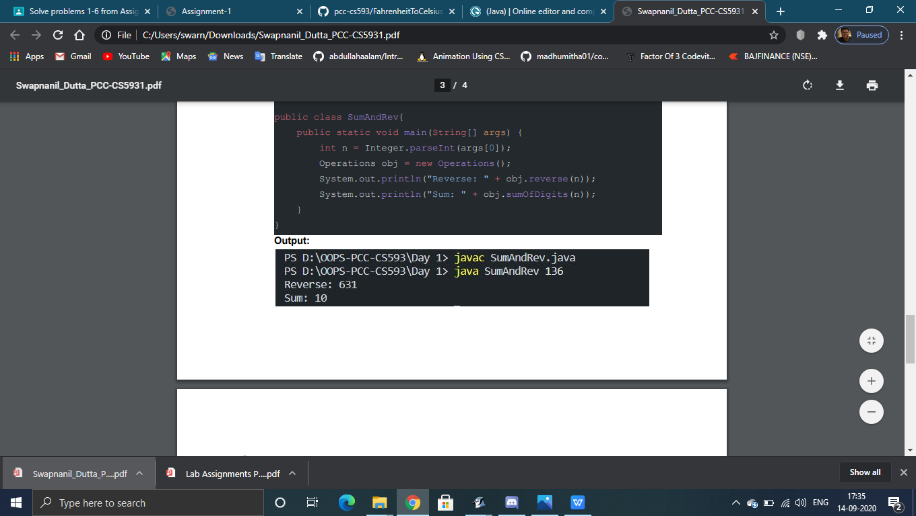

Program 6

import java.util.*;

public class Factorial_Recursion

{

public static int facto(int n)

{

if (n == 0)

return 1;

return n * facto(n - 1);

}

public static void main(String[] args)

{

Scanner sc=new Scanner(System.in);

int num = sc.nextInt();

System.out.println("Factorial: " + facto(num));

}

}

